The Summer Bridging Work MUST be handed in to your Music teacher by Friday 13 September 2019.

Your work will be assessed in September by your class teachers.

Anyone not completing the work or producing work of poor quality will be re-interviewed regarding their place on the course and in the Sixth Form.

The aims are for you to understand if you like the course and for you to be ready to start learning at post-16 level.

All work is due in on Friday 13 September 2019.

Things you will need to succeed every day in the Sixth Form:
- Pens
- Highlighters
- A pencil case
- Your own lined paper
- A single-hole punch (available from the school shop for £1)
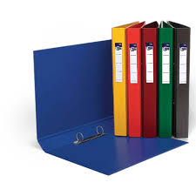
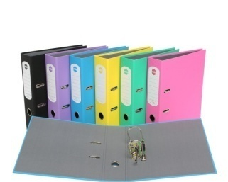
- A pair of scissors
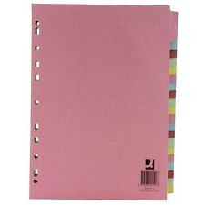
- Glue

Things you will need for this course:
- A lever-arch folder for storing work at home
- A ring-binder for work for the current unit
- A pack of at least 20 file dividers
- Your own good quality headphones

The books you need to buy are:
You will directed in September to the books you need to buy and will be able to buy these at a reduced cost through the music department.

Task 1 – Performance | You need to prepare a solo performance. This should be unaccompanied and should demonstrate your style and flair on your chosen instrument. You will ideally perform a piece that is between grade 6 – grade 8 standard, although this is not essential. You will need to provide a photocopy of the score for your teacher and your performance will be recorded for analysis.
Task 2 - Composition | You need to compose three different starting points for compositions based on the below scenarios. These only need to be ideas and not a completed composition (it should be a maximum of 32 bars, minimum of 16 bars).  - Compose a musical prelude as incidental music for a County Youth theatre production of Shakespeare’s ‘Macbeth’. You may compose for any appropriate combination of instruments or voices.  - Compose an instrumental piece in theme and variation form, to be performed by instrumentalists in a Young Composers competition organised by the County. You are advised to compose an original theme, and to ensure sufficient development in the variations.  - Compose a piece in ternary form intended for inclusion in a chamber music concert at the local music college. You may write for any appropriate combination of instruments.
Task 3 – Listening | Read and listen to each of the sections on the following website on ‘A Short History of Music’  https://alevelmusic.com/4-short-history-of-music/  You will need to make notes on each section and revise this in preparation for a test in September.

A-Level Music Summer Bridging Work 2019

Staff contact: Miss Jackson (lja@cheney.oxon.sch.uk)
Mr Barquilla (jbq@cheney.oxon.sch.uk)

Exam board: Eduqas A Level Music

Specification: http://www.eduqas.co.uk/qualifications/music/as-a-level/eduqas-a-level-music-spec-from-2016-d.pdf?language_id=1

