The Summer Bridging Work MUST be handed in to your Drama teacher by Friday 13 September 2019.

Your work will be assessed in September by your class teachers.

Anyone not completing the work or producing work of poor quality will be re-interviewed regarding their place on the course and in the Sixth Form.

The aims are for you to understand if you like the course and for you to be ready to start learning at post-16 level.

All work is due in on Friday 13 September 2019.

Things you will need to succeed every day in the Sixth Form:
- Pens
- Highlighters
- A pencil case
- Your own lined paper
- A single-hole punch (available from the school shop for £1)
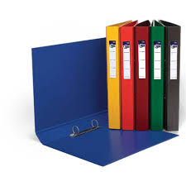
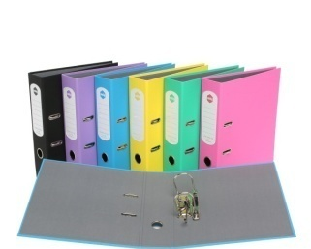
- A pair of scissors
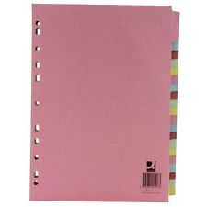
- Glue

Things you will need for this course:
- A lever-arch folder for storing work at home
- A ring-binder for work for the current unit
- A pack of at least 10 file dividers
- Comfortable clothes that are easy to work in

The books you need to buy are:
N/A we will provide the textbooks and exercise books you will need to use.

A-Level Drama Summer Bridging Work 2019

Task one: Research one of the practitioners listed below. Your research should include a short biography, methodologies and techniques, plays/performances that have been created or inspired by the practitioner.
Peter Brook - acting approaches
Augustus Boal - Theatre of the oppressed
DV8 - Physical theatre/multimedia/verbatim
Gordon Craig - Designer

Task two: Write a review on how a live (or recorded if not possible) performance impacted you as an audience member.
Both of these will be presented as a presentation style workshop that could also include a practical workshop that focuses on the methodologies of the chosen practitioner.

Staff contact: Miss Johnson (ejh@cheney.oxon.sch.uk)

Exam board: AQA A Level Drama and Theatre

Specification: https://filestore.aqa.org.uk/resources/drama/specifications/AQA-7262-SP-2016.PDF

