Applied Science (Single)

The Summer Bridging Work MUST be handed into one of your subject teachers by Friday 13 September 2019.

Your work will be assessed in September by your class teachers.

Anyone not completing the work or producing work of poor quality will be re-interviewed regarding their place on the course and in the Sixth Form.

The aims are for you to understand if you like the course and for you to be ready to start learning at post-16 level.

All work is due in on Friday 13 September 2019.

Things you will need to succeed every day in the Sixth Form:
- Pens
- Highlighters
- A pencil case
- Your own lined paper
- A single-hole punch (available from the school shop for £1)
- A pair of scissors
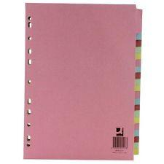
- Glue

Things you will need for this course:
- A lever-arch folder for storing work at home
- A ring-binder for work for the current unit
- A pack of at least 20 file dividers
- A Scientific calculator
- A ruler
- Summer Bridging Work Applied Science

The books you need to buy are:
There are a number of textbooks available for this course. Students in the past have found BTEC National Applied Science Revision Guide: (with free online edition) a good option.

Your Summer Bridging Work Project:
Context: You are a trainee cell biologist newly employed at a research facility in their cell culture lab. Any contamination of the immortalised animal cells you are culturing is disastrous. Bacterial contamination means that all the cells being cultured under the cell culture hood or in the room itself must be destroyed and the room and all the equipment in it cleaned.
You must be able to show you can recognise the key features and differences in both the internal and external morphology of both bacterial and animal cells.
Task: Provide a hand drawn annotated diagram of both an animal and bacterial cell, you must include internal features and provide a table stating the function of each organelle. Conclude your report by describing the key differences and similarities between the cells.
For prokaryote cells (bacterial cell) you should include the following organelles: nucleoid; plasmids; 70S ribosomes; capsule and cell wall.
For eukaryotic cells (animal cells) you should include the following organelles: plasma membrane; cytoplasm; nucleus; nucleolus; endoplasmic reticulum (smooth and rough); Golgi apparatus; vesicles; lysosomes; 80S ribosomes; mitochondria and centriole.
Below you should find an example of a good quality piece of work from a previous year’s year 12.

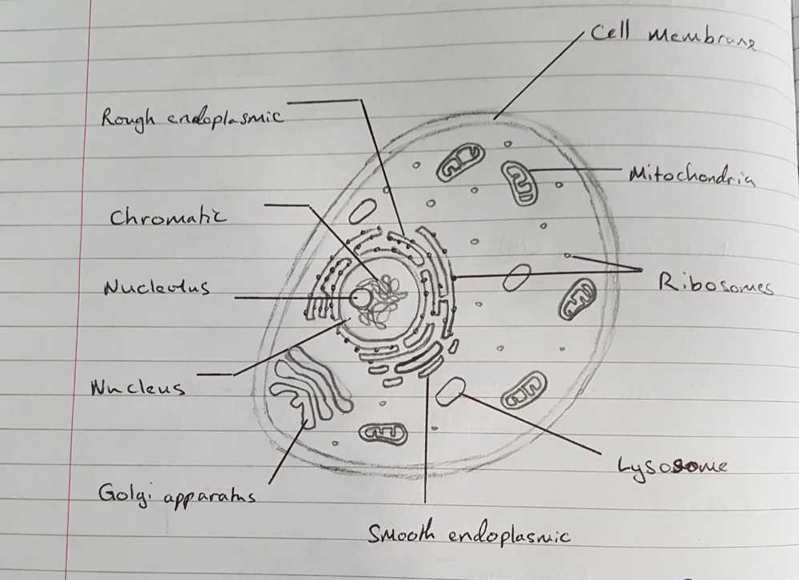

To produce a good scientific drawing you should:
- Use a sharp pencil
- Do not shade or colour. Use stippling to show darker areas.
- Title your drawing
- Use a ruler to draw label lines; do not use arrows. Do not cross label lines.
- Print all labels horizontally.

Staff contact: Mr Routledge: KRO@cheney.oxon.sch.uk
Mr Preston: BPR@cheney.oxon.sch.uk
Miss Seller: ESE@cheney.oxon.sch.uk

Exam board: Pearson

Specification:
https://qualifications.pearson.com/en/qualifications/btec-nationals/applied-science-2016.html

