**Art**

**The Summer Bridging Work MUST be handed into one of your subject teachers by Friday 14 September 2019**

**Your work will be assessed in September by your class teachers.**

**Anyone not completing the work or producing work of poor quality will be re-interviewed regarding their place on the course and in the Sixth Form.**

**The aims are for you to understand if you like the course and for you to be ready to start learning at post-16 level.**

**All work is due in on Friday 13 September 2019**

**Things you will need to succeed every day in the Sixth Form:**

* Pens
* Highlighters
* A pencil case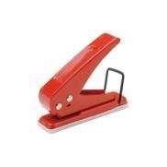
* Your own lined paper
* A single-hole punch (available from the school shop for £1)
* A pair of scissors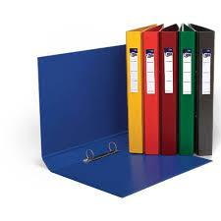
* Glue

**Things you will need for this course:**

* A Camera
* Summer Bridging Work
* A portfolio + Materials ( Art - available from the art office)

**Your Summer Bridging Work Project:**

**Using composition skills learnt from your freshers photoshoot.**

**-** Create 3 drawings under the title Holiday, use Martin Parr for inspiration. You can use a medium of your choice.

- **A written piece** on a contemporary artist who relates to your own ideas – min 500 words

- **Visit a gallery**

Document your visit with notes, photographs and sketches.