The Summer Bridging Work MUST be handed in to your Music teacher by Friday 13 September 2019.

Your work will be assessed in September by your class teachers.

Anyone not completing the work or producing work of poor quality will be re-interviewed regarding their place on the course and in the Sixth Form.

The aims are for you to understand if you like the course and for you to be ready to start learning at post-16 level.

All work is due in on Friday 13 September 2019.

Things you will need to succeed every day in the Sixth Form:
- Pens
- Highlighters
- A pencil case
- Your own lined paper
- A single-hole punch (available from the school shop for £1)
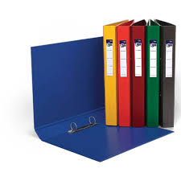
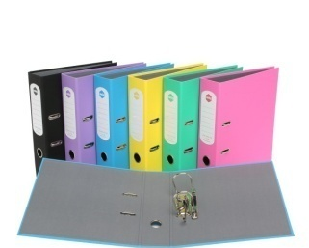
- A pair of scissors
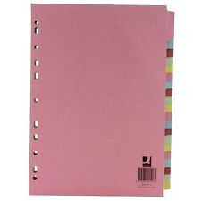
- Glue

Things you will need for this course:
- A lever-arch folder for storing work at home
- A ring-binder for work for the current unit
- A pack of at least 20 file dividers
- Your own good quality headphones

The books you need to buy are:
You will directed in September to the books you need to buy and will be able to buy these at a reduced cost through the music department.

Task 1 - Performance | On fresher’s day, you chose a song to develop ready for a performance in September. Over the summer you need to learn your individual part of this song so you are ready to rehearse as an ensemble in September in preparation for a performance. This performance will be recorded in order to be analysed and used in preparation of the Ensemble Performance unit.
Task 2 – Music Theory | One of the units focuses on music theory. We will cover a lot of this during lessons, but in order to prepare yourself for this, you need to complete the below.  Go to musictheory.net and click on lessons. You need to complete the lessons for the below topics and make notes on each lesson. Your notes will be submitted. Once you have completed the lessons and created your notes, go to exercises and complete the exercises that correspond to the lessons. Record your scores. Do not worry about the scores at this point – we have time to develop, but practicing these regularly will give you a head start for this unit!  Lessons to cover:  - The staff, clefs and ledger lines  - Note duration  - Measures and time signature  - Rest duration  - Dots and ties  - Steps and accidentals  - Simple and compound meter  - Odd meter  - The major scale  - The minor scale  - Scale degrees  - Key signatures  - Key signature calculation  - Generic intervals  - Introduction to chords  - Triad inversion  - Phrases and cadences

BTEC Music Summer Bridging Work 2019

Staff contact: Miss Jackson (lja@cheney.oxon.sch.uk)
Mr Barquilla (jbq@cheney.oxon.sch.uk)

Exam board: Pearson BTEC Level 3 National Extended Certificate in Music Performance

Specification: https://qualifications.pearson.com/content/dam/pdf/BTEC-Nationals/Music/2017/Specification/9781446928110_BTEC_Nat_ExtCert_Music_Spec_prepubfinal.pdf

