The Summer Bridging Work MUST be handed into the Sixth Form on Friday 13 September 2019.

Your work will be assessed in September by your class teachers.

Anyone not completing the work or producing work of poor quality will be re-interviewed regarding their place on the course and in the Sixth Form.

The aims are for you to understand if you like the course and for you to be ready to start learning at post-16 level.

All work is due in on Friday 13 September 2019.

Things you will need to succeed every day in the Sixth Form:
- Pens
- Highlighters
- A pencil case
- Your own lined paper
- A single-hole punch (available from the school shop for £1)
- A pair of scissors
- Glue
Things you will need for this course:
- A lever-arch folder for storing work at home
- A ring-binder for work for the current unit
- A pack of at least 20 file dividers

The books you need to buy are: N/A We will provide the textbook we would like you to use.

Your Summer Bridging Work Project:
This is a work booklet that Miss Falconer will provide for you in the ‘taster’ session.
Staff contact: Miss Falconer: afc@cheney.oxon.sch.uk

Exam board: Edexcel

Specification: http://qualifications.pearson.com/content/dam/pdf/BTEC-Nationals/Sport/20161/specification-and-sample-assessments/Specification-Sport-National-Extended-Certificate.pdf

Wider Reading and Discovery List: Sport Science/Physical Education
Introduction to your course (I can use the blurb from the Options Booklet if you like – just let me know)

Books
- Revise BTEC National Sport Revision Guide (2016), ISBN 9781292150482, Pearson Publishing
- Revise BTEC National Sport Revision Workbook (2017), ISBN 9781292150475, Pearson Publishing. (available for pre-order)
- Schmidt, R.A. & Wrisberg, C.A. (2004). ‘Motor Learning and Performance’ (3rd Edition). Champaign, IL: Human Kinetics Publishers.
- Schmidt, R.A., & Lee, T.D. (2005). ‘Motor Control & Learning – A Behavioural Emphasis’ (4th Edition). Champaign, IL: Human Kinetics Publishers.
- Cox, R.H. (2007). Sport Psychology: Concepts and Applications. (6th edition). New York: McGraw-Hill.
- Berger, B., Pargman, D., & Weinberg, R. (2002). Foundations of Exercise Psychology. Morgantown, WV: Fitness Information Technology.
- Gill, D.L. (2000/2008). Psychological Dynamics of Sport and Exercise (2nd/3rd edition). Champaign, IL. Human Kinetics.
- Moran, A. (2004). Sport and Exercise Psychology: A Critical Introduction. London: Routledge.
- Weinberg, R.S., & Gould, D. (2003/2007). Foundations of Sport and Exercise Psychology. (3rd or 4th edition). Champaign, IL: Human Kinetics.
- John Lowerson (1995) Sport and the English Middle Class 1870 – 1914, Manchester University Press
- Neil Wigglesworth (1996) The Evolution of English Sport, Frank Cass
- Dennis Brailsford ( 1998 ) British Sport A Social History, Lutterworth Press
- Jay Coakley (1998) Sport and Society Issues and Controversies, McGraw Hill
- Simon Barnes (2006) The Meaning of Sport
- Ellis Cashmore ( 2005) Making Sense of Sport, Routledge

Websites
- http://www.brianmac.co.uk/index.htm
- http://www.bbc.co.uk/history/british/victorians/sport_01.shtml
- http://news.bbc.co.uk/sport1/hi/academy/default.stm
- www.olympic.org
- www.einet.net/review/83726-526768/Sir_Norman_Chester_Centre_for_ Football_Research_University_of_Leicester.htm
- www.london2012.com
- www.eis2win.co.uk
- www.youthsporttrust.org
- www.sportengland.org/

Things to do
- www.visitlondon.com/sport/sports_calendar/
- Wimbledon Tennis Championships - Last week of June , first week in July
- Cricket Tests - Lords and the Oval
- Rugby Internationals - the six nations - Twickenham
- Football internationals - Wembley
- Oxbridge Boat Race - April - Putney Bridge
- Doggett Coat and Badge - July - London Bridge
- London Marathon - April
- PGA Golf - Wentworth
- Grand Prix Athletics - Crystal Palace - July
- Rugby Museum - Twickenham
- Tennis Museum - Wimbledon
- MCC Museum - Lords - Home of the Ashes
- Hampton Court Palace - Royal Tennis Court
- River and Rowing Museum - Henley

BTEC National Level 3 Extended Certificate in Sport
2019-21 Summer Bridging Work

Student Name - .
Assessor – A Falconer
I.V.- A Ransome
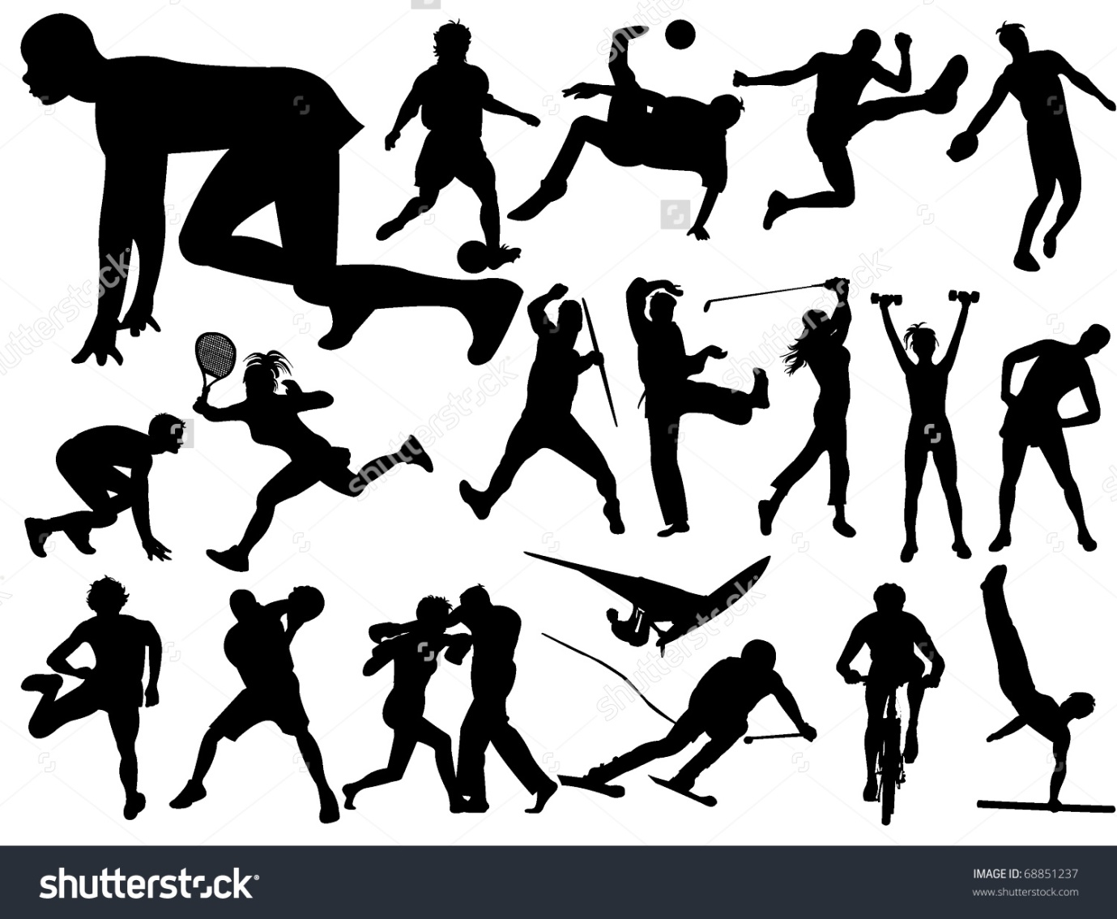
Unit 1: Anatomy and Physiology - involves a 1 ½ hour exam based on a 80 mark paper. Your summer bridging work requires you to complete this booklet, learning some of the key terms that will be included in the exam. We will have a test in September, with a target score being set for all of you.

Bones
The axial skeleton is the part of the skeleton that consists of the bones of the head and trunk of a vertebrate.

The human appendicular skeleton is composed of the bones of the upper limbs, the lower limbs, the pectoral girdle, and the pelvic girdle.

Using the list of bones below, select the appropriate bones and annotate the diagrams.

cranium, clavicle, ribs, sternum, scapula, humerus, radius, ulna, carpals, metacarpals, phalanges, pelvis, vertebral column (cervical, thoracic, lumbar, sacrum, coccyx), femur, patella, tibia, fibula, tarsals, metatarsals.
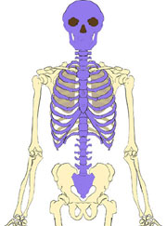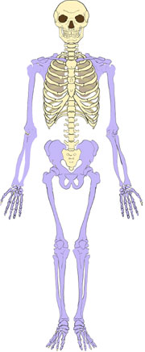

Joints
Classify each joint into the appropriate column in the table.
Joints – Hip, Knee, Shoulder, Ankle, Wrist, Elbow, Cervical Vertebrae, Lumber Vertebrae, Sacrum Vertebrae, Thoracic Vertebrae, Coccygeal Vertebrae.
Joints of the Upper Skeleton | Joints of the Lower Skeleton

Classification of joints
There are 3 classifications of Joint - fibrous (fixed), cartilaginous (slightly moveable), synovial (freely moveable). Draw or print an example of each of these joints and state where in the body you would locate it.

Fibrous Cartilaginous Synovial

Synovial Joints are split into 6 types. Can you match each picture to the type of synovial joint?

Pivot Hinge Saddle Plane/Gliding Condyloid Ball-and-socket

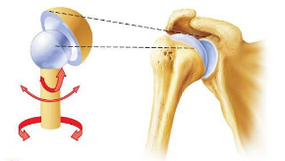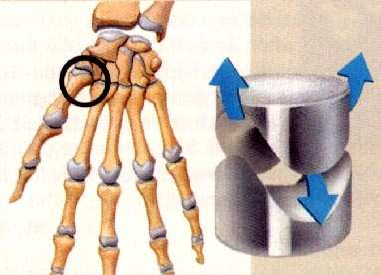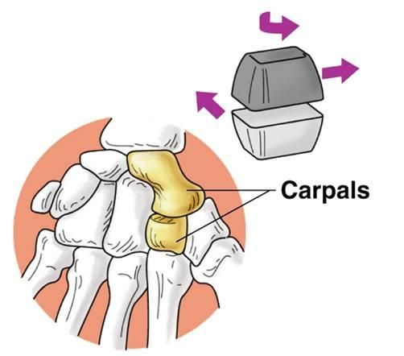
______ ___________ _______________ __________________

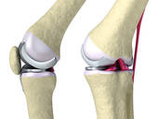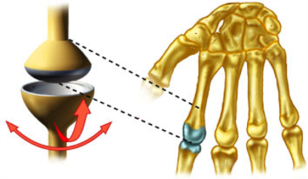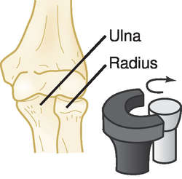

____________________ ________________________ ___________________

Muscles
Label the Anterior and Posterior views of the muscular system inputting the following muscles.
Deltoids, biceps, triceps, wrist flexors, wrist extensors, supinators and pronators, pectorals, abdominals, obliques, quadriceps, hip flexors, tibialis anterior, erector spinae, trapezius, latissimus dorsi, gluteals, hamstrings, gastrocnemius, soleus.

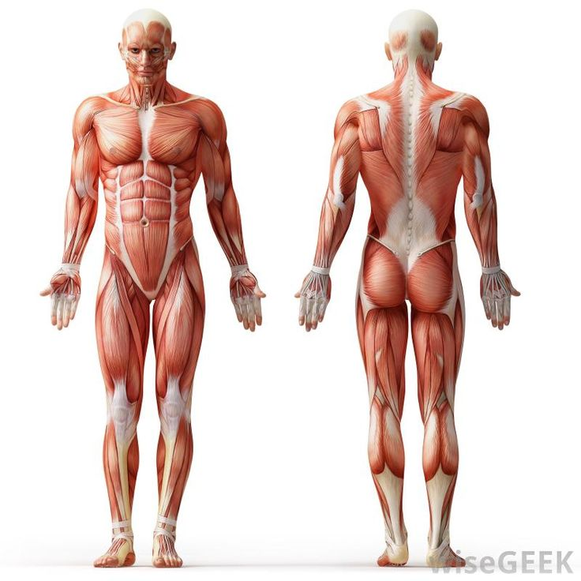
Complete the table
Type of muscle | Characteristics | Example of muscle(s)
Cardiac | non-fatiguing, involuntary
Skeletal | fatiguing, voluntary
Smooth | involuntary, slow contraction

List 5 functions of the skeletal system.
1) Protection – The axial skeleton protects the vital organs
2) Sh
3) Su
4) Bl C P
5) M
Types of Joint Movement
Type | Definition | Sporting Example
Flexion | Decreasing the angle between articulating bones. | Raising forearm during Bicep curl
Extension
Abduction
Adduction
Rotation
Circumduction
Plantarflexion
Dorsiflexion
Pronation
Supination
Eversion
Inversion

Types of Muscular Contraction
Using an arrow link the correct term to its definition:

Isotonic same distance/not moving

Isometric same speed

Isokinetic same tension

Describe each of these contractions and explain how each are required during performance in a sport of your choice.
________________________________________________________________________________________________________________________________________________________________________________________________________________________________________________________________________________________________________________________________________________________________________________________________________________________________________________________________________________________________________________________________________________________________________________________________________________________________________________________________________________________________________________________________________________________________________________________________________________________________________________________________________________________________________________________________________________

