The Summer Bridging Work MUST be handed into one of your subject teachers by Friday 13 September 2019.

Your work will be assessed in September by your class teachers.

Anyone not completing the work or producing work of poor quality will be re-interviewed regarding their place on the course and in the Sixth Form.

The aims are for you to understand if you like the course and for you to be ready to start learning at post-16 level.

All work is due in on Friday 13 September 2019.

Things you will need to succeed every day in the Sixth Form:
- Pens
- Highlighters
- A pencil case
- Your own lined paper
- A single-hole punch (available from the school shop for £1)
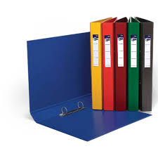
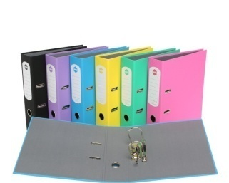
- A pair of scissors
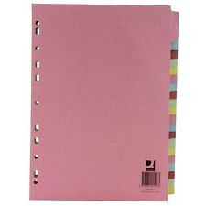
- Glue

Things you will need for this course:
- A lever-arch folder for storing work at home
- A ring-binder for work for the current unit
- A pack of at least 20 file dividers
- A Scientific calculator
- A ruler
- Summer Bridging Work biology

The books you need to buy are:
AQA Biology A-Level 2nd Edition. Glenn Toole & Susan Toole. ISBN 978-0-19-835177-1 You will need to buy this book. You will be able to purchase this at a reduced cost in September

Your Summer Bridging Work Project:
- Each student is to research a range of sources (e.g. internet, scientific journals, newspapers, magazines, leaflets, TV programmes, interviews with experts etc..) on a particular disease caused by a microorganism

- Present your own research in the form of an informative and detailed A3 sized poster

What areas should the poster cover?
- Your poster should give sufficient information to address the following questions:
    - What is the disease?
    - What organism causes the disease?
    - How does it infect the body?
    - What effect does it have on the body’s systems?
    - How can the disease be prevented and treated?
    - What impact does the disease have on society?

- TIP: if you run out of space on your A3 sheet – add more information on the other side of the sheet (to produce a double-sided information sheet)

What else do I need to do?
- On a separate sheet of A4 paper, produce a list of all sources/references that you have used in the production of your poster (with sufficient information on each reference so that it can be easily located by another person)
- Attach your reference list to your poster
- Be prepared to give a brief (~2 mins) presentation on the contents of your poster and what you have found out about your chosen disease

Staff contact: Mr Finch: FMA@cheney.oxon.sch.uk
Mrs Lynch: BLY@cheney.oxon.sch.uk
Miss Seller: ESE@cheney.oxon.sch.uk

Exam board: AQA

Specification:
http://www.aqa.org.uk/subjects/science/as-and-a-level/biology-7401-7402

Wider Reading and Discovery List:

Magazines/journals
- New Scientist
- Scientific American
- Nature
- Science
- Biological Sciences Review
- British Medical Journal
- Any scientific articles in newspapers (e.g. the Guardian on Wednesday)

Books
- The Greatest Show on Earth by Richard Dawkins. Bang up to date on the evidence for evolution- a great introduction to evolution.
- The Origin of Species by Charles Darwin (the final chapter- although it is all very well written).
- Why Evolution is True by Jerry Coyne (one of the best single volume introductions to evolutionary theory)
- Bad Science by Ben Goldacre- very good on the scientific method and how science works.
- The Selfish Gene by Richard Dawkins (a classic, if difficult read).
- River out of Eden by Richard Dawkins.
- Genome by Matt Ridley (very good on modern developments in genetics).
- Life by Richard Fortey (excellent on fossil evidence and the history of life).
- A Short History of Nearly Everything by Bill Bryson.
- Mapping the Deep by Robert Kunzig
- Silent Spring by Rachel Carson
- Almost Like A Whale by Steve Jones

Places of Interest-Oxford
- Natural History Museum
- Botanical Gardens
- Harcourt Arboretum

Websites
- http://www.cellsalive.com/
- http://www.yourgenome.org/
- http://nature.com – The site of the scientific journal
- http://www.nhm.ac.uk – The London Natural History Museum’s website with lots of interesting educational material
- http://www.bbc.co.uk/news/science_and_environment - The BBC news page for Science and the Environment

