The Summer Bridging Work MUST be handed in to you subject teacher by Friday 13 September 2019.

Your work will be assessed in September by your class teachers.

Anyone not completing the work or producing work of poor quality will be re-interviewed regarding their place on the course and in the Sixth Form.

The aims are for you to understand if you like the course and for you to be ready to start learning at post-16 level.

All work is due in on Friday 13 September 2019.

Things you will need to succeed every day in the Sixth Form:
- Pens
- Highlighters
- A pencil case
- Your own lined paper
- A single-hole punch (available from the school shop for £1)
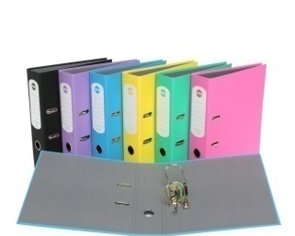
- A pair of scissors
- Glue
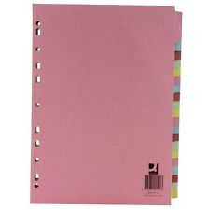
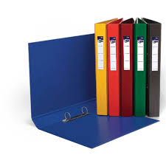
Things you will need for this course:
- A lever-arch folder for storing work at home
- 2 ring-binders for work for the current unit
- and assessments
- A Flashdrive

The books you may want to buy are:

OCR AS and A Level - Computer Science; PM Heathcote and RSU Heathcote; PG ONLINE
ISBN: 978-1-910523-05-6

Your Summer Bridging Work Project:

Guidance

Either use tutorials from: w3schools (which is more detailed) or Codecademy, complete the HTML and CSS learning modules.

This will prepare you for JavaScript (which you should learn for the problem solving question paper and the A ‘level project in second year).

When you finish the modules, you are to create a website with at least 4 pages using HTML and CSS (some JavaScript is optional but encouraged). The website should be on computing related topics below:

Suggested topics in computing for this work: (These are also possible sources for 9 mark questions)

TOPIC A: Computing related legislation
  - The Data Protection act 1998
  - The Computer Misuse Act 1990
  - The Copyright Design and Patents Act 1988
  - The regulation of Investigatory Powers

TOPIC B: Ethical, moral, cultural issues and risks of digital technology
- Computers in the workforce
- Automated Decision Making
- Artificial Intelligence
- Environmental effects
- Censorship and the internet
- Monitor behaviour
- Analyse personal information
- Piracy and Offensive communications

For both topics try to search and reference the latest news articles and stories for examples..

(Do not cheat by using a web authoring program (e.g. Dreamweaver) to create your website).

Staff contact: Mr P. Magagula – email address (pma@cheney.oxon.sch.uk)

Exam board: OCR

Specification: Please click here for the full specification

