Geography

The Summer Bridging Work MUST be handed into one of your subject teachers by Friday 13 September 2019. Your work will be assessed in September by your class teachers.

The aims are for you to understand if you like the course and for you to be ready to start learning at post-16 level.

Things you will need to succeed every day in Geography:
· Pens
· Highlighters
· A pencil case
· Your own lined paper
· A single-hole punch (available from the school shop for £1)
· A pair of scissors
· Glue

Things you will need for this course:
· A lever-arch folder for storing work at home
· A ring-binder for work for the current unit
· A pack of at least 10 file dividers
· Pencils
· Ruler
Make sure you keep work for the two halves of the course separate

You may like to have your own copy of the text book:
Year 1: https://global.oup.com/education/product/9780198366454/?region=uk
Year 2: https://global.oup.com/education/product/9780198366485/?region=uk

Your Summer Bridging Work Project:

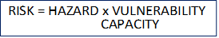
PART A (1)
Natural Hazards research notes AND essay.
Research the earthquake in Nepal using the equation to help organise your research.

You should have notes on each of the sections, perhaps in a spider diagram annotating the equation. You must include:
· SPECIFIC DETAIL (ie numbers, facts, names of places and dates).
· A RANGE of different issues and ideas
· BALANCE between the different sections of the essay

Then: Answer the question in no fewer than 400 words:
‘Why was the risk so high in Nepal when the earthquake hit?’

Part A (2)
Globalisation: Have low cost airlines, like easyjet, helped to accelerate the process of globalisation?

Task: Your task is to create case study notes (at least 1 full page A4) that summarise how low cost airlines have accelerated the process of globalisation. Our case study will focus on easyjet. You may use the extract attached as a starting point but you must complete additional research online.

Use the following headings to create your case study:
• How the company has grown
• How it grew into a TNC
• The role of technology in its growth
• The effect that easyJet has on places in adds to its flight network

PART B
You need to choose a book from the list below to read and write a book review for.
150 word summary
150 word link to Geography
150 word thoughts, opinions, questions you may have.

Fiction

· White Tiger, Aravind Adiga. An exciting account of India today.
· Call the Midwife, Jennifer Worth – fascinating tale of life in the East End in the 1950s, before the regeneration.
· Two Caravans, Marina Lewycka – A humorous tale of some migrant workers in the UK
· No Bad News for the King, Emma Larkin - The True Story of Cyclone Nargis and Its Aftermath in Burma
Non-fiction
· The Map that changed the world, Simon Winchester
· Krakatoa, Simon Winchester,
· The Gaia Hypothesis, James Lovelock
· No Logo, Naomi Klein
· Cowley Road, Annie Skinner
· Collapse, Jared Diamond

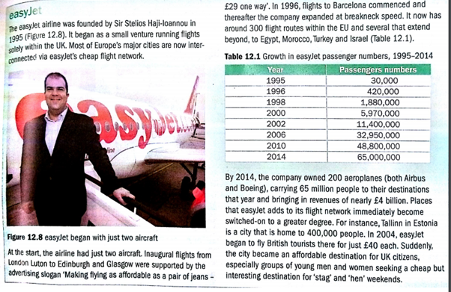

Staff contact: Mr Lea: ele@cheney.oxon.sch.uk

Exam board: Edexcel

Specification: http://qualifications.pearson.com/en/qualifications/edexcel-a-levels/geography-2016.html

Wider Reading and Discovery List:

Books
- Cowley Road, Annie Skinner
- The Map that changed the world, Simon Winchester
- Krakatoa, Simon Winchester,
- The Gaia Hypothesis, James Lovelock
- The no-nonsense guide to world poverty (New Internationalist)
- No Logo, Naomi Klein
- Three Cups of Tea, Greg Mortenson
- Collapse, Jared Diamond

Magazines/Journals
- New Internationalist
- The Economist
- New Scientist
- The Week
- Any broadsheet newspaper

Websites
- BBC News
- http://policy-practice.oxfam.org.uk/
- http://www.nationalgeographic.com/
- www.wateraid.org.uk

Things to do
- Visit the Weather exhibit in the Science Museum, London
- Visit the Museum of London
- Visit the Natural History and Pitt Rivers museums in Oxford
- Visit the Olympic site and local, regenerated area.
- Visit the London Transport Museum
- Spend some time in Jericho, Oxford and see the regeneration of the old industrial area.
- Head over to the Thames Barrier to see the flood defence.
- Visit the Natural History Museum in London for their tectonic exhibit.
- Make sure you attend the advertised Geography Association Lectures in Oxford. There are also some Royal Geographic Society lectures in central London that you could go to – google it!

Things to watch
· An Inconvenient Truth – Al Gore’s Academy Award winning documentary about climate change
· 11th Hour – with and produced by Leonardo DiCaprio, this explores solutions for restoring the world’s ecosystems
· Black Gold – ‘Wake up and smell the coffee’
· The Impossible – a terribly sad story following a family through the Asian Tsunami of 2004
· Hotel Rwanda – the tale of the genocide through the eyes of a hotel owner and his efforts to help
· Blood Diamond – staring Leonardo DiCaprio, this is the story of where our diamonds come from and the immense cost to human life
· Lord of War – staring Nicholas Cage, this explores the life of an illegal arms dealer
· The End of Poverty – fascinating documentary about development

Things to listen to
- Radio 4 – The World Tonight

