**The Summer Bridging Work MUST be handed into one of your subject teachers by Friday 6th September 2019.**

**Your work will be assessed in September by your class teachers.**

**Anyone not completing the work or producing work of poor quality will be re-interviewed regarding their place on the course and in the Sixth Form.**

**The aim is for you to understand if you like the course and for you to be ready to start learning at post-16 level.**

**All work is due in on Friday 6th September 2019.**

## Things you will need to succeed every day in the Sixth Form:

* Pens
* Highlighters
* A pencil case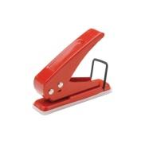
* Your own lined paper
* A single-hole punch (available from the school shop for £1)
* A pair of scissors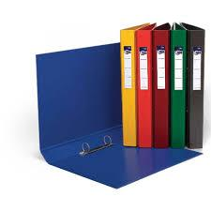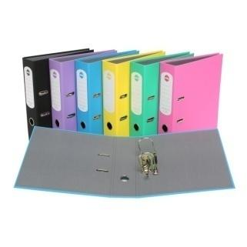
* Glue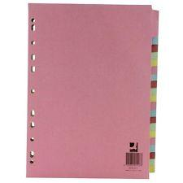

**Things you will need for this course:**

* A lever-arch folder for storing work at home
* A ring-binder for work for the current unit
* A pack of at least 6 file dividers

## The books you need to buy are:

* *The Handmaid’s Tale (ISBN: 9780099740919)*
* *Frankenstein*
* *Poems of the Decade: An Anthology of the Forward Books of Poetry 2002 -2011*(ISBN: 978 – 0571325405)
* *Selected poems: John Keats* (ISBN: 9780140424478)
* *Twelfth Night*
* *The Importance of Being Earnest*

# Your Summer Bridging Work Project:

**Please consult the main document on this. But in short: Read a post - 2000 literary text and write a proposal (of about 300 words) arguing for its literary worth. Why will/should your text be read in a 100 years as opposed to others? Prepare to argue your case to the class.**

**Staff contact:** Mr B. Knott [bkn@cheney.oxon.sch.uk](mailto:bkn@cheney.oxon.sch.uk)

**Exam board:** Edexcel

**Specification:** [**https://qualifications.pearson.com/en/qualifications/edexcel-a-levels/english-literature-2015.html**](https://qualifications.pearson.com/en/qualifications/edexcel-a-levels/english-literature-2015.html)

**Wider Reading and Discovery List:**

Please refer to the hand out you have been given