Cheney School Freshers’ Day 24 24 June 2019

9.00-9.15am | Registration | Sixth Form Team | Assembly Hall
9.15-10.00am | Welcome Assembly | Sixth Form Team | Assembly Hall
10.00-10.30am | Break – please use L1 and L2 as your year areas.
10.30-11.30am | Period 2 | Option A Teacher | Option A Room
11.35-12.35pm | Period 3 | Option B Teacher | Option B Room
12.35-1.05pm | Lunch – please use L1 and L2 as your year areas.
1.05-2.05pm | Period 4 | Option C Teacher | Option C Room
2.10-3.00pm | Period 5 | Option D Teacher | Option D Room
3.00-3.30pm | Please join us for some refreshments and a game of rounders!
3.30-4.00pm | Twilight | Twilight Teacher | Twilight Room
Any other comments
How do I use my Private Study Period?
- Start the Summer Bridging Work for each of your subjects (school website)
- Sign up for the Pre-University Skills course on Futurelearn, a six-week, certified UEA course: https://www.futurelearn.com/courses/preparing-for-uni
- Download, save & read the specs for each of your subjects (links are on the Summer Bridging Work)
- Find out more about and sign up for DofE Gold
- Sign up for your Volunteering
- Meet your SSLT and find out how to get involved
- Meet some Year 12s and find out what Sixth Form is really like
- Find out more about Apprenticeships
- Meet the school nurse and find out about what support we can give you
- Confirm your contact information
Welcome to Cheney School Sixth Form Freshers’ Day 2019

We are delighted to welcome you to our Freshers’ Day. The next two years are an important stage in your life and we look forward to working with you to make sure you achieve your best and make the right decisions about what you go on to do after Sixth Form.

Over the course of today, we hope that you will get a good flavour of what it’s like to be a part of the Sixth Form and what life will be like for you over the next two years. You’ll have the chance to meet subject staff, the Sixth Form Super Tutors, the Sixth Form mentors – the whole Sixth Form team. Please ask them any questions you may have – everyone is here to help! It is incredibly important to us that you feel welcome, and above all, happy at Cheney.

Sixth Form is a challenge but if you take all the amazing opportunities available to you, it promises to be some of the best years of your life. We have a real ‘family’ atmosphere in the Sixth Form and we think you’ll agree it is a great place to be.

We hope that you enjoy today and we look forward to seeing you again in September.

Best wishes,

Ms Hackett Dr Rayment Ms Greenbank
Mr Gimson Dr Casson Ms Patel
Ms Warbrick Ms Jackson Ms Berry
Ms Loring Ms Mortimer
Mrs Broom

Telephone: +44 (0) 1865 755306
Email: sixthform@cheney.oxon.sch.uk

The Sixth Form Team

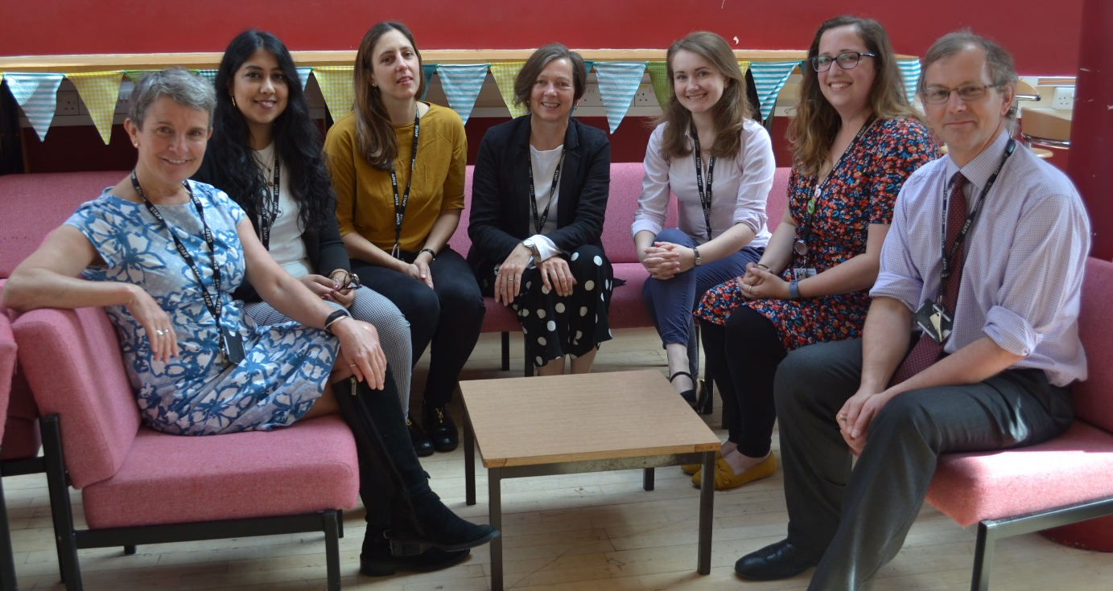

Ms Warbrick (Pastoral Leader), Ms Patel (Super Tutor), Ms Mortimer (Super Tutor), Ms Hackett (Head of Sixth Form), Ms Greenbank (Super Tutor), Ms Berry (Super Tutor), Mr Gimson (Super Tutor)

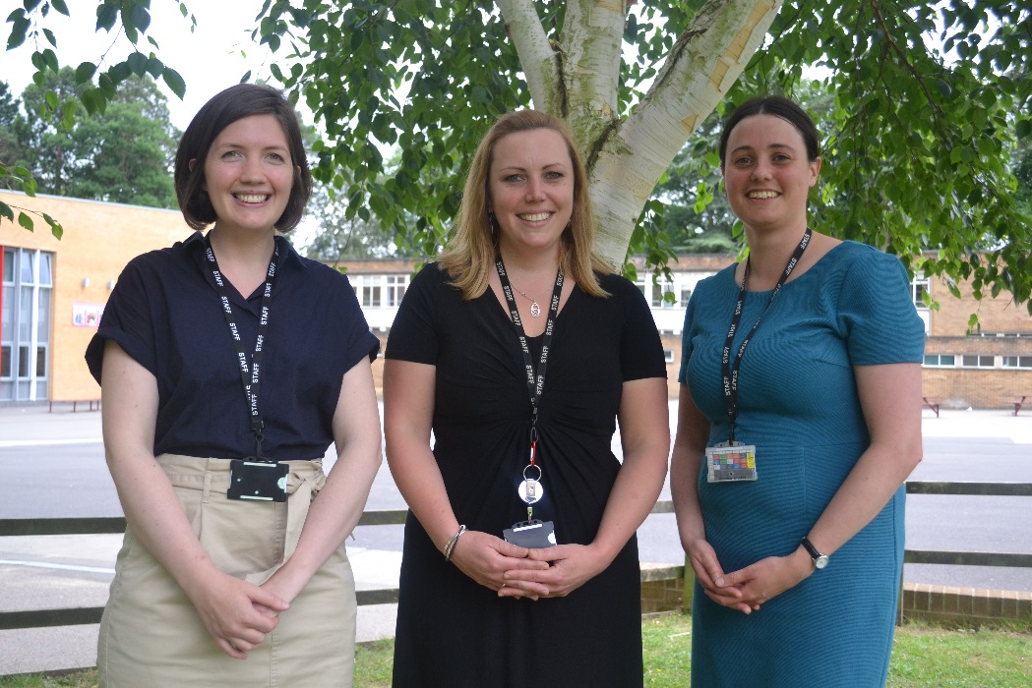

Dr Rayment (Deputy Head of Sixth Form), Ms Jackson (Mentor), Dr Casson (Mentor)

Please come and speak to any of us today if you have any problems, concerns, questions or comments.
Key Dates

Date | Event
Thursday 22 August | GCSE Results Day – please confirm your Sixth Form plans
Friday 23 August | Last day to confirm your Sixth Form plans (Library)
Monday 2 September, 8.30am | Term 1 Starts: Year 12 – Bright Futures (Register in the Sixth Form) Area
Thursday 12 September | Meet the Tutors evening
Friday 13 September | Final date for submission of Summer Bridging Work
Week beginning 21 October | Short report home
23 October | Term 1 Ends
4 November | Term 2 Starts
13 November | Year 12 Information Evening
19 December | Term 2 Ends
7 January | Term 3 Starts
7 Jan – 10 Jan | Year 12 Mock Exams: off timetable (some students may have exams the following week, but will not be on study leave)
14 February | Term 3 Ends
24 February | Term 4 Starts
3 March | Careers Convention evening
4 March | Sixth Form Conference (day time)
11 March | UCAS information evening
12 March | Trip to Brunel University for UCAS Convention
3 April | Term 4 Ends
20 April | Term 5 Starts
22 May | Term 5 Ends
1 June | Term 6 Starts
1 June – 5 June | Year 12 UCAS Predictor Exams
8 June – 12 June | Year 12 Work Experience
25 June | Parents’ Evening
17 July | End of School Year
Reminder: the school day will be 8.30am-3.10pm for Term 1 of Year 12. Further freedoms will be introduced gradually from Term 2.

