The Summer Bridging Work MUST be handed into the Sixth Form on Friday 13th September 2019.

Your work will be assessed in September by your class teachers.

Anyone not completing the work or producing work of poor quality will be re-interviewed regarding their place on the course and in the Sixth Form.

The aims are for you to understand if you like the course and for you to be ready to start learning at post-16 level.

All work is due in on Friday 13th September 2019.

Things you will need to succeed every day in the Sixth Form:
- Pens
- Highlighters
- A pencil case
- Your own lined paper
- A single-hole punch (available from the school shop for £1)
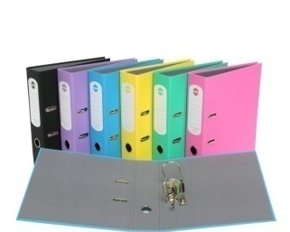
- A pair of scissors
- Glue
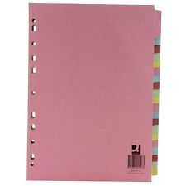
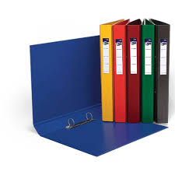
Things you will need for this course:
- A lever-arch folder for storing work at home
- A ring-binder for work for the current unit
- A pack of at least 40 file dividers
- Plastic wallets

The books you need to buy are:

OCR A Level History: England 1485–1603 by Nicholas Fellows, Mary Dicken (Hodder, ISBN 9781471836695),19.99

Revolution in France by Josh Brooman (Longman, ISBN 0 582 08254 4, currently available for 1p plus £2.80 postage and packing from numerous sellers on Amazon). This is the best simple introduction

Your Summer Bridging Work Project:

The Later Tudors
Mandatory (this work will be checked)
- Create a timeline for the reigns of Edward VI, Mary I and Elizabeth I. The three main themes of the course are government, religion and rebellion. You should colour code your timeline according to these three areas. You will have to research the key events. The more detail you include the more useful it will be. Feel free to be creative in the construction of the timeline; images, cartoons and interesting facts would be excellent!
- Make a glossary containing a minimum of the following words:
-Reformation
-Catholic
-Papacy
-Protestant
-Eucharist
-Communion
-Anabaptist
-Royal supremacy
-Enclosure
Uniformity

- Research and make profiles on the following individuals:
-The Duke of Northumberland
-The Duke of Somerset
-William Cecil
-Robert Dudley
Optional (if you are aiming for a top grade we suggest you do this)
- Watch historian David Starkey’s documentary on Elizabeth (available for free on YouTube). If you type ‘Starkey Elizabeth’ into the YouTube search bar it will come up. It is split into s number of sections.
- Listen to the podcasts available at the following link. These are created by experts in the topics and will give you an engaging and useful introduction to the course. We suggest you do this after you have completed the timeline so you already have some knowledge about the topics that are being discussed. You should listen to the following podcasts:

-The English Reformation
-Mary Tudor
-Tudor Rebellions: Henry VII-Elizabeth I
-Elizabeth I and Spain: The road to war
-Poverty under the Tudors
-The Role and Function of Parliaments during the Tudor period

If you would like to listen to the other podcasts in the series they would be useful background but they are not required.
This is the link for the podcasts: http://www.history.org.uk/resources/student_resource_4139.html

The French Revolution
The French Revolution and Napoleon: read Revolution in France by Josh Brooman. Create a scrapbook or folder with at least 20 colour A4 images or maps, illustrating in chronological order, the key events of the French Revolution. Annotate these pictures carefully to describe the information, or the impression which they are trying to create. Use key terms to start to build your confidence with the vocabulary you will need to talk confidently about the Revolution. Please see below for an example.

Example:

This film is a very good starting point: The French Revolution Part 1: La Révolution française Les Années Lumières
https://www.youtube.com/watch?v=ST-kzGnzBaw

Exam board: OCR

Specification: http://www.ocr.org.uk/Images/170209-specification-accredited-as-level-gce-history-a-h105.pdf

Wider Reading and Discovery List:

Books
Elizabeth I and Religion by Susan Doran (a brilliantly readable and short introduction to religious issues under Elizabeth)
Elizabeth I by Christopher Haigh
The BBC History Magazine’s Tudor issue: http://www.historyextra.com/news/tudors/story-tudors-sale-now
Historical novels set during the Tudor era (e.g. CJ Sansom and Hilary Mantel)
God’s Traitors: Terror and Faith in Elizabethan England by Jessie Childs
The History of England-Volume 2: The Tudors by Peter Akroyd
Magazines/Journals
- BBC History
- History Today

Websites
- National Archives
- British Library
- http://www.johnguy.co.uk/

Things to do
In Oxford
- Visit the Ashmolean Museum
- Go on a walking tour of Oxford
- Visit Oxford Castle

In London:
- The Imperial War Museum
- Churchill War Rooms
- National Gallery/National Portrait Gallery
- Victoria and Albert Museum

Things to watch
- Crash course introduction to the Protestant Reformation: https://www.youtube.com/watch?v=1o8oIELbNxE
- A documentary on the reigns of Edward VI and Mary I: https://www.youtube.com/watch?v=5mRFbmSga_4
- Short video on Tudor succession: https://www.youtube.com/watch?v=h2tfXu6eJzE&index=4&list=PL0E58471D20026FFE
- Documentary on Elizabeth I:
https://www.youtube.com/watch?v=pV2GKPtnlTo
- A short introduction to the Elizabethan Age:
https://www.youtube.com/watch?v=18VyKi3_Di4

