Maths. Summer Bridging Work.

REQUIRED:
Problems section…

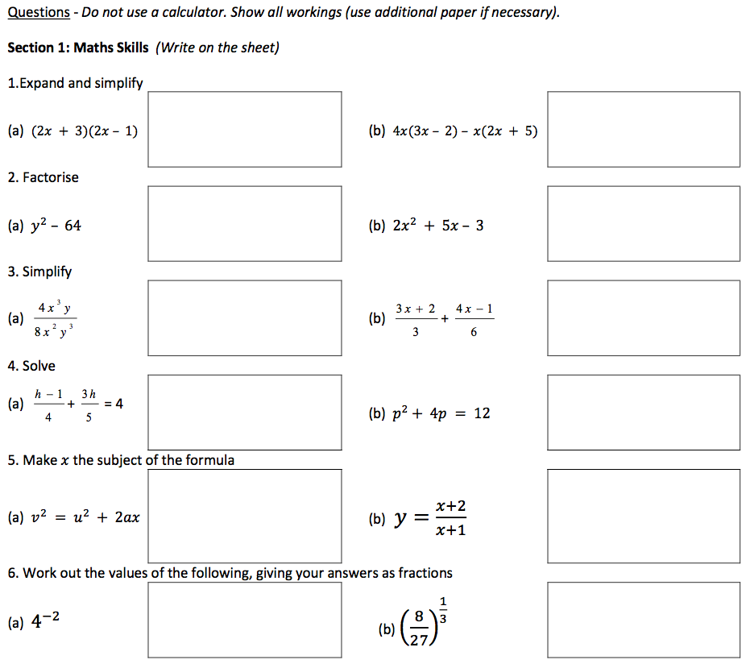
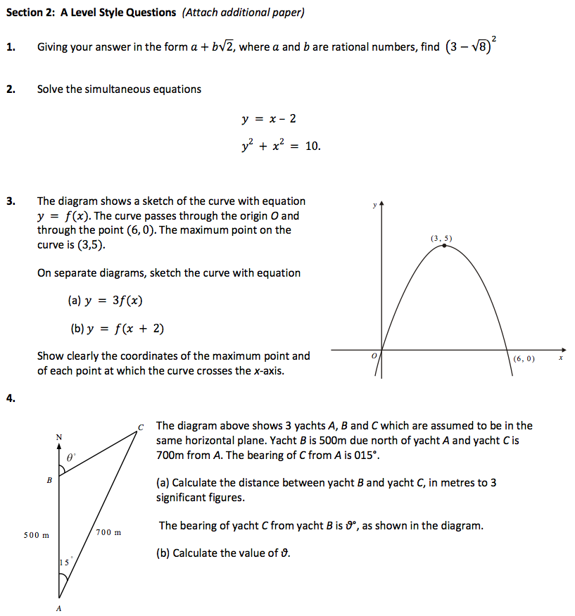
*
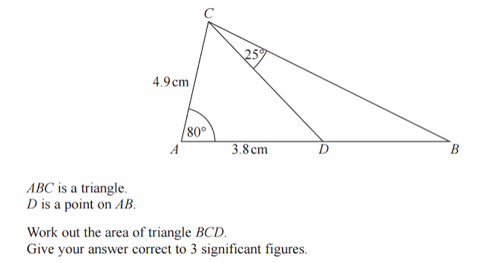
**
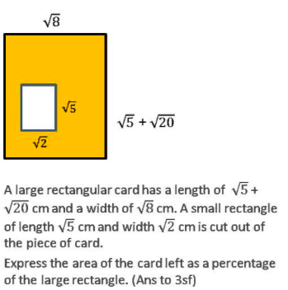

***

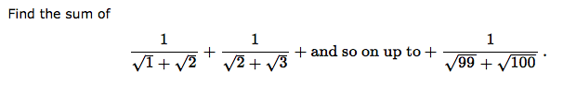

OPTIONAL

Research:
Listen to this “In Our Time” podcast by Melvin Bragg. (These are an excellent resource for extra research). Make notes and attach them to the bridging work.
http://www.bbc.co.uk/programmes/p00545hk
