Media Studies Bridging Work 2019
“Today we live in a society in which spurious realities are manufactured by the media, by governments, by big corporations, by religious groups, political groups... So I ask, in my writing, What is real? Because unceasingly we are bombarded with pseudo-realities manufactured by very sophisticated people using very sophisticated electronic mechanisms. I do not distrust their motives; I distrust their power. They have a lot of it. And it is an astonishing power: that of creating whole universes, universes of the mind. I ought to know. I do the same thing.”
― Philip K. Dick 1978
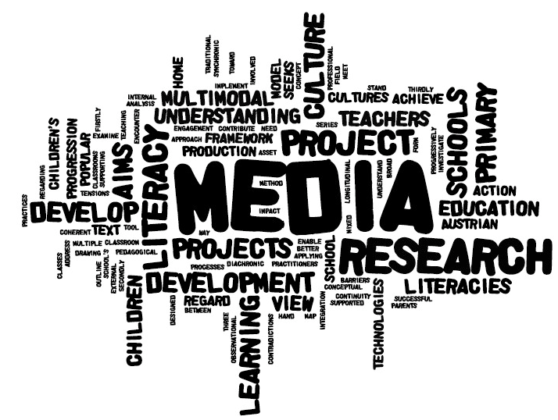
Welcome to your preliminary work for the Media Studies A Level, which you will begin studying from September 2019. To get you ready for the course, we need you to start thinking about Media, what it is, how it functions and tells us stories about the world around us.
Task One - The Media and You
What is media? Can you write your own definition, then compare it to a dictionary definition?
My definition: Dictionary definition:
How do you use and consume media? Keep a diary for three days in which you note down all the media you interact with.
Days | Social Media Used | Broadcast / Moving Image media consumed | Print Media consumed | Advertising seen | Games
Day One
Day Two
Day Three
Time spent

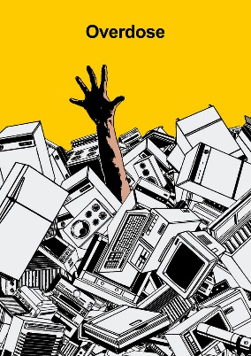

Task Two - Thinking about the News
Where we get news from and how it’s presented can shape our opinions and how we view what is happening in the world.
Choose a topic you are interested in from the following list:
- The Royal Family
- Climate Change
- Brexit
Find two news stories from the same day from two different news sources from the following list, choosing one from each column

Tabloids / Middle Markets | Quality Press / Broadsheets
The Sun  The Daily Mirror  The Daily Express  The Daily Mail | The Guardian  The Independent  The Times  The Financial Times

Make a mind map for each story, on how it is presented by the paper, including the following points:
- Amount of text on the page
- Use of colour
- Use of headlines
- Type of language used
- Use of images
Extensions
Can you find the same stories on the websites and online outlets of the same papers? Is there anything different about them? Make some notes on what you discover.
Task Three Advertising
Find an advert for one of the following products, and make notes on who you think the product is aimed at, in terms of age and interests.

- A personal fragrance
- A soft drink or energy drink
- A healthy snack product

Write up your notes using these sentence starters

The product I have chosen is …

I think it is aimed at …

I think this is the target audience because …

The story the advert tells is ….

Task Four: Engaging with text types
Complete two of tasks from this list and make notes on what you find interesting about the texts, using the framework below

- Watch the film E.T
- Watch the film Stand by Me
- Listen to the Radio 1 Breakfast show
- Listen to the Smooth Radio Breakfast Show
- Watch the music video for Beyoncé’s If I was a Boy
- Watch the music video for Sia’ Elastic Heart

The main focus of the text was …

I think the target audience would be ….

I accessed this media by ….

I think the representations of people were making points about ….

The story the texts were trying to tell was about …

