The Summer Bridging Work MUST be handed in to your Physics teachers by Friday 13 September 2019.

Your work will be assessed in September by your class teachers.

Anyone not completing the work or producing work of poor quality will be re-interviewed regarding their place on the course and in the Sixth Form.

The aims are for you to understand if you like the course and for you to be ready to start learning at post-16 level.

All work is due in on Friday 13 September 2019.

Things you will need to succeed every day in the Sixth Form:
- Pens
- Highlighters
- A pencil case
- Your own lined paper
- A single-hole punch (available from the school shop for £1)
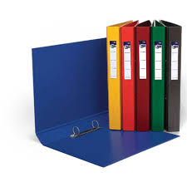
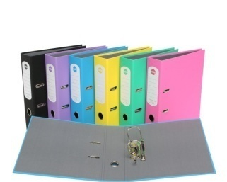
- A pair of scissors
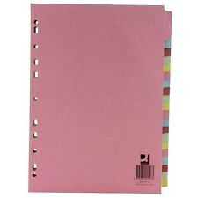
- Glue

Things you will need for this course:
- A lever-arch folder for storing work at home
- A ring-binder for work for the current unit
- A pack of at least 20 file dividers
- A Scientific calculator
- Graph paper
- Protractor and ruler

The books you need to buy are:
CGP A-level Physics for AQA: Year 1 and AS Student book. ISBN 978 1 78294 323 5. You will need to buy this book. You will be able to purchase this at a reduced cost in September

You may also want to purchase an A-level Physics revision guide if you prefer summarised notes. Just make sure it is for the new (starting 2015, exams 2016/7) A-level and for AQA.

Physics Summer Bridging Work 2019
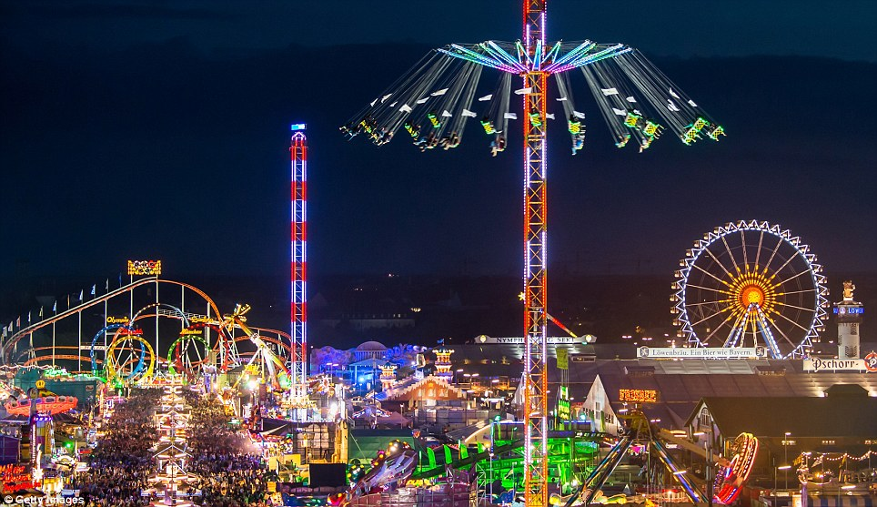
Here is a picture of a fairground. Your task is related to the physics going on in the picture and involves describing a little bit about each topic. You are welcome to think about what is going on inside the rides or even to imagine what some of the harder-to-see rides could be. You will be sharing your work in an early Physics lesson in September. More detail on what to include is on the next page.

Task 1 – matter  For particle physics teacher | The fairground is all made from matter. Physics is the science which concentrates the most on the nucleus of an atom so…  Research Task: WHAT’S INSIDE AN ATOMIC NUCLEUS?  What are the basic “ingredients” of matter? How did we discover them?  Research format: 1 typed side of A4, with NAME of the STUDENT, DATE and TITLE at the top. Please use 12pt font. At least one small diagram would be expected but larger diagrams should be on a second page. Diagrams should be hand drawn. Please staple pages.  Suggested Sources:  http://resources.schoolscience.co.uk/STFC/16plus/partich1pg2.html  http://www.absorblearning.com/chemistry/demo/units/LR302.html  http://www.dummies.com/how-to/content/the-nucleus-the-center-of-an-atom.html
Task 2 – mechanics  For mechanics teacher | The fairground rides are all to do with movement so…  Point out several rides in the picture and explain what is going on in terms of movement and why this makes then exciting.  Use ideas of acceleration, force, circular motion, pendulum motion, energy etc. Support your explanations with diagrams and equations.  Work format: 1 side of A3, with NAME of the STUDENT, DATE and TITLE at the top. Please stick the picture of the fairground in the middle and add handwritten labels, diagrams and descriptions of what’s going on.  http://www.bbc.co.uk/schools/gcsebitesize/science/triple_aqa/using_physics_make_things_work/  http://www.bbc.co.uk/education/topics/zmj7hyc
Task 3 – materials  For materials teacher | The fairground rides are made from what they are because of the bulk properties of the matter they are made from.  Research Task: WHAT’S HAPPENS WHEN A STEEL CABLE IS STRETCHED?  And how are cables tested to ensure they’re safe for uses like fairground rides?  Research format: 1 side of typed A4, with NAME of the STUDENT, DATE and TITLE at the top. Please use 12pt font. Diagrams and sketch graphs would be expected and should be hand drawn on a second page. Please staple pages. Suggested Sources:  http://physicsnet.co.uk/a-level-physics-as-a2/materials/  http://www.bbc.co.uk/schools/gcsebitesize/science/21c_pre_2011/materials/
Staff contact: Dr Hardwick dha@cheney.oxon.sch.uk
Mr Routledge kro@cheney.oxon.sch.uk
Dr Casson cca@cheney.oxon.sch.uk

Exam board: AQA A level Physics 7408

Specification: http://filestore.aqa.org.uk/resources/physics/specifications/AQA-7407-7408-SP-2015.PDF

Wider Reading and Discovery List:

Become a member of the Institute of Physics (IOP) and get a free Physics World magazine regularly https://applications.iop.org/16to19.aspx

Visit any of Oxford’s excellent science museums.

Visit the Science Museum, Imperial war museum, the planetarium or Greenwich observatory in London.

Or the National Space Centre (Leicester).

Read popular science/physics books (Christmas isn’t too far away!) e.g.

- A short History of Nearly Everything - Bill Bryson
- Why don’t penguins’ feet freeze? – NewScientist
- The Grand Design – Stephen Hawkin and Leonard Mlodinow
- Newton – Peter Ackroyd
- The Quantum Universe: Everything that can happen does happen – Brian Cox and Jeff Forshaw

Watch physics or space programs on iPlayer (best to go to the science category and just scroll past the nature stuff).

Or just search Amazon or YouTube (or even snapchat for all I know) for “Physics” and you will find more amazing physics facts, conundrums and ideas than I can even imagine – so please tell us about them!

