The Summer Bridging Work MUST be handed into one of your subject teachers by Friday 13 September 2019.

Your work will be assessed in September by your class teachers.

Anyone not completing the work or producing work of poor quality will be re-interviewed regarding their place on the course and in the Sixth Form.

The aims are for you to understand if you like the course and for you to be ready to start learning at post-16 level.

All work is due in on Friday 13 September 2019.

Things you will need to succeed every day in the Sixth Form:
- Pens
- Highlighters
- A pencil case
- Your own lined paper
- A single-hole punch (available from the school shop for £1)
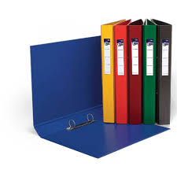
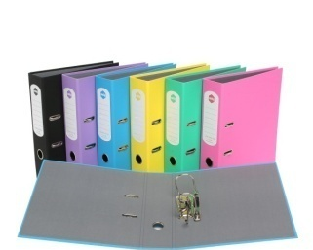
- A pair of scissors
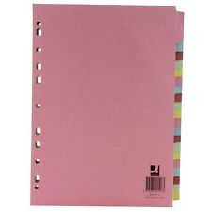
- Glue

Things you will need for this course:
- A lever-arch folder for storing work at home
- A ring-binder for work for the current unit
- A pack of at least 3 file dividers

The books you need to buy are:

OCR A level Sociology 1-(purple colour)

OCR A level Sociology 2-(purple colour)

Your Summer Bridging Work Project:

Sociological Methods

Task 1
Having good definitions of key methodological terms is critical to success in A2. Examiners report that candidates often confuse terms or fail to provide sufficient data and explanation. Draft some definitions that provide illustrations and explanations for the following concepts. Make your definitions as clear and as well illustrated as possible:

Objectivity

Validity

Ethics

Reliability

Representativeness

Generalisability

Operationalising

Rapport

Verstehen

Content analysis

Task 2
Explain each of the research methods in the table below.
 | Explain these research methods using examples. | Completed: YES/NO
1 | - Questionnaires  - Statistical data  - Content analysis
2 | - Statistical data / personal documents  - Observation (participant / non participant)  - Longitudinal studies
3 | - Case studies  - Pilot studies  - Triangulation / methodological pluralism
4 | - Structured interviews  - Semi structured interviews  - Unstructured interviews
5 | - Focus groups and group interviews

Wider Reading and Discovery List: See table below.

 | Topic | Activities / resources in class:
1 | What will the following five weeks entail?  How do I progress to A2 – what work needs completing?  What will the homework be? | Run through p1-6. Show exemplars of Key Study summary and Methods Summary. Complete task 1a, 1b and 2 – emphasis key terms – validity, reliability, rep , gen, ethics.
2 | What are Quantitative methods and Positivism? | Key Study 1 British Crime Survey  http://www.youtube.com/watch?v=jzdTiM5wS_c  Steve Taylor clip about the ‘dark figure’ – could work as intro  http://www.youtube.com/watch?v=jvUNuAC-O1Y  Election debate – Tory on why he doesn’t like BCS – not very good quality – only a couple of minutes  http://www.ons.gov.uk/ons/rel/crime-stats/crime-statistics/year-ending-december-2011/stb-crime-stats-dec-2011.html  Latest summary of data from what is now known as The Crime Survey for England and Wales
3 | What is the British Crime Survey? Are the methods used valid, reliable, ethical, objective, rep and gen?
4 | What are Qualitative methods and Interpretivism? | Key study 2: Venkatesh  http://www.youtube.com/watch?v=yRq1AhFAN-4  Venkatesh talks about the research – 4 minutes  http://www.sudhirvenkatesh.org/biography  His personal website – find out more about him  Book review  http://www.nytimes.com/2008/01/16/books/16grimes.html  http://www.youtube.com/watch?v=4YH0LUt8R2k  9 minutes gang documentary for background/starter
5 | What was Venkatesh’s study? Are the methods used valid, reliable, ethical, objective, rep and gen?
6 | What are Mixed meths and realism? | - X:\SociologyHumanitiesHSC\Lesley's Sociology Talky Clips – click on the quant / qual clip to see a debate between Paul and Lesley on this area.
7 | What is Gillies’ study? Are the methods used valid, reliable, ethical, objective, rep and gen?
8 | What are Feminist methods? | Key study 4  Oakley  http://www.annoakley.co.uk/  Includes extract with interview segment  http://www.pregnancyforum.org.uk/  link to pregnancy discussion / questions – good starter  DVD of Oakley talking available
9 | What was Oakley’s study? Are the methods used valid, reliable, ethical, and objective, rep and gen?
10 | What are Values?
11 | What is Becker’s study? Are the methods sued valid, reliable, ethical, objective, rep and gen? | Becker  http://www.youtube.com/watch?v=wY7ztWzItkg&feature=relmfu
12 | What is Sampling and content analysis?
13 | What is Poole’s study? Are the methods used valid, reliable, ethical, objective, rep and gen? | Key study 6  Islamophobia  http://www.youtube.com/watch?v=MNoV4GsijHA  Report on Islamophobia 3 mins  http://www.youtube.com/watch?v=OYD3EOqOKpQ&feature=relmfu  http://www.youtube.com/watch?v=CDc_VzE75Zg&feature=relmfu  two parts of radio 4 programme about Islamophobia in the press and TV – with still images – second better – both 12 mins  http://www.iengage.org.uk/resources/useful-links?start=1  links on Islamophobia including the key study
14 | What are Longitudinal and case studies? What is the 7 up study? Are the methods used valid, reliable, ethical, objective, rep and gen? | Key study 7  Seven Up series  Loads on Youtube  http://www.telegraph.co.uk/culture/tvandradio/9206960/Seven-Up-Now-we-are-56.html
15 | What are Interviews?
16 | What are the studies by Labov / Dale? Are the methods used valid, reliable, ethical, objective, rep and gen?

Staff contact Mrs Makwezva:wma@cheney.oxon.sch.uk
Mr Taberer: BTA@cheney.oxon.sch.uk

Exam board: OCR

Specification: H580

