**The Summer Bridging Work MUST be handed into the Sixth Form on Monday 9 September 2019.**

**Your work will be assessed in September by your class teachers.**

**Anyone not completing the work or producing work of poor quality will be re-interviewed regarding their place on the course and in the Sixth Form.**

**The aims are for you to understand if you like the course and for you to be ready to start learning at post-16 level.**

**All work is due in on Monday 9 September 2019.**

## Things you will need to succeed every day in the Sixth Form:

* Pens
* Highlighters
* A pencil case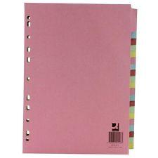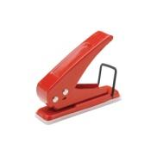
* Your own lined paper
* A single-hole punch (available from the school shop for £1)
* A pair of scissors
* Glue

**Things you will need for this course:**

* An A4 exercise book provided by school for each language teacher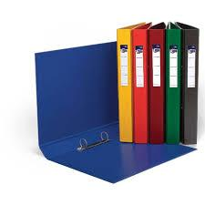

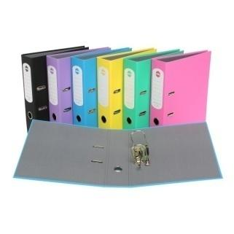

## The books you need to buy are:

* A large French-English dictionary to keep at home
* “Un sac de billes” study guide <https://www.hoddereducation.co.uk/subjects/languages/products/16-18/modern-languages-study-guides-un-sac-de-billes>
* “Intouchables” study guide (<https://www.hoddereducation.co.uk/subjects/languages/products/16-18/modern-languages-study-guides-intouchables> - £11.99)
* A French A Level Grammar Workbook (<https://www.hoddereducation.co.uk/subjects/languages/products/16-18/french-a-level-grammar-workbook-1-> £6.99)
* “Un sac de billes” – Joseph Joffo - ‘le livre de poche 5641. Edition 58 – fevrier 2017.’ It’s the version that has the film poster as the book cover and is 285 pages long. DON’T get the larger copy with larger font, or the English version. NOT the ‘livre de poche jeunesse’ version. It’s this one: <https://livre.fnac.com/a186987/Joseph-Joffo-Un-sac-de-billes>

# Your Summer Bridging Work Project:

We expect you to do a lot of **independent work** and self study. You all have different strengths & development points, and it is up to you to address these. Let us know if you are struggling & need extra input from either of us.

As part of a more independent approach to learning you should expect to make your own **notes** in class without being asked. Make sure as much new vocabulary as possible is recorded and then learnt. Also be sure to make notes on facts about each topic area.

Lessons will be **conducted in French / German /Spanish** for the majority of the time – please make the effort to talk to us and each other in French / German / Spanish!

Now, let’s get started so you are confident when you come back...

**Core tasks on Grammar**

* Write a French grammar Bible which should include notes on:

1. present regular – er / ir / re verbs
2. irregular present tense verbs (avoir, aller, devoir, être, faire, venir)
3. the imperfect
4. the future
5. the conditional
6. the perfect tense
7. the pluperfect

Each tense should be clearly explained on an A4 page.

**You should explain a) how these are formed**

**b) when they are used**

**c) patterns and exceptions**

**d) tips on how to remember them.**

**Revise all this over the summer in preparation for a test first lesson in September!**

**Core tasks on Reading, Listening, Speaking and Writing**

* Go to [www.euronews.com](http://www.euronews.com) to keep up to date with French current affairs at least once a week. Read the transcript if you find listening too difficult. Choose at least one event over the summer that you will be presenting to the class.
* Watch “Un sac de billes” film to give you a head start before studying the book.

* Read the prologue and Chapter 1 of “Un sac de billes” to give you an introduction to French literature but please do not go any further as you will be studying the book chapter by chapter as a class.

**Extension tasks**

* Read any French articles online or in French magazines so you get familiar with different styles of writing and extend your vocabulary. Prepare 1 minute presentation on one of them.
* Watch as many French films as listening and cultural enhancement. PLEASE DO NOT WATCH “Intouchables”

**Staff contact: Mlle Sophie Reynes sr@cheney.oxon.sch.uk**

**Exam board:** EDEXCEL

**Specification:** A level French