**The Summer Bridging Work MUST be handed into Dr. Bown on Monday 2 September 2019.**

**Your work will be assessed in September by your class teachers: Dr. Bown.**

**Anyone not completing the work or producing work of poor quality will be re-interviewed regarding their place on the course and in the Sixth Form.**

**The aims are for you to understand if you like the course and for you to be ready to start learning at post-16 level.**

**All work is due in on Monday 2 September 2019.**

## Things you will need to succeed every day in the Sixth Form:

* Pens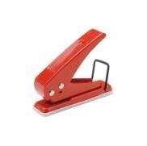
* Highlighters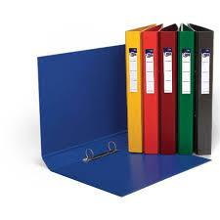
* A pencil case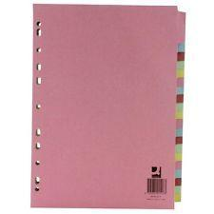
* Your own lined paper
* A single-hole punch (available from the school shop for £1)
* A pair of scissors
* Glue
* four small ring binders and file dividers

## 

## The books you need to buy are:

* *Sansibar Oder Der Letzte* Grund Paperback by Alfred Andersch. Diogenes Verlag AG,Switzerland (30 Sept. 2006)

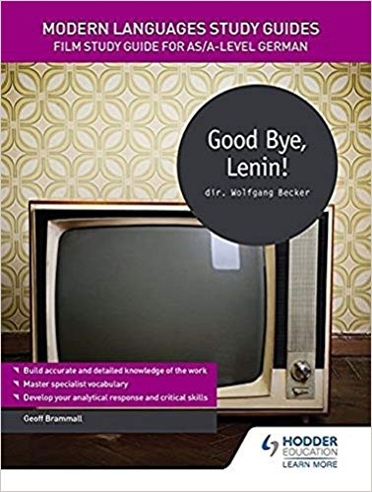

* *Modern Languages Study Guides: Good Bye, Lenin!: Film Study Guide for AS/A-level German* (Film and literature guides) Paperback by Geoff Brammall Hodder Education (28 April 2017)
* *AQA A Level German: Grammar & Translation Workbook* Paperback by [Dagmar Sauer](https://www.amazon.co.uk/s/ref=dp_byline_sr_book_1?ie=UTF8&field-author=Dagmar+Sauer&search-alias=books-uk&text=Dagmar+Sauer&sort=relevancerank) OUP Oxford; 2 edition (14 Sept. 2017)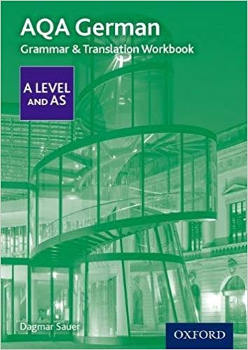

# Your Summer Bridging Work Project:

We expect you to do a lot of **independent work** and self study. You all have different strengths & development points, and it is up to you to address these. Let me know if you are struggling & need extra input. My email is [rbo@cheney.oxon.sch.uk](mailto:rbo@cheney.oxon.sch.uk).

As part of a more independent approach to learning you should expect to make your own **notes** in class without being asked. Make sure as much new vocabulary as possible is recorded and then learnt. Also be sure to make notes on facts about each topic area.

Lessons will be **conducted in German** for the majority of the time – please make the effort to talk to us and each other in German! Now, let’s get started so you are confident when you come back...

**Core grammar task**

* Write a Spanish grammar Bible which should include notes on:

i) present regular verbs

ii) stem-changing verbs (present)

iii) irregular present tense verbs (sein, haben)

iv) separable verbs (in present, past and future)

v) reflexive verbs and modal verbs (in present, past and future)

vi) verbs followed by the dative

vii) the perfect tense with haben

viii) the perfect tense with sein

ix) the imperfect tense

x) the past perfect

xi) the conditional

xii) the future

Each tense should be clearly explained on an A4 page.

**You should explain a) how these are formed**

**b) when they are used**

**c) patterns and exceptions**

**d) tips on how to remember them.**

**Also prepare at least one page about definite and indefinite articles and adjective endings and the case system: nominative, accusative, dative.**

**Revise all this over the summer in preparation for a test first lesson in September!**

**Core Reading and Listening Tasks**

* Go to [www.euronews.com](http://www.euronews.com) at least once a week and watch videos to keep up to date with German current affairs. Read the transcript if you find listening too difficult. Choose at least one event over the summer that you will be presenting to the class.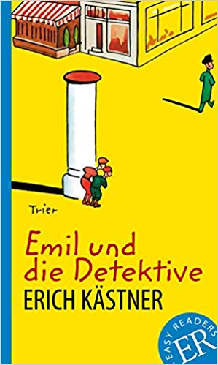
* Read a photocopy of *Emil und die Detektive* - handed out in June. Look up words you don’t know and write them on the page. I should see on average at least 10 words per page.

**Extension tasks**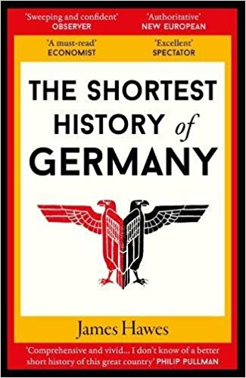

* Read James Hawes’ *The Shortest History of Germany Old Street Publishing; Later Edition edition (1 April 2018)*
* Read three or more articles online from the *Spiegel Online* website. Prepare a 1 minute presentation on one of them.
* For further challenge, you could try reading any of the following books. They are all on the A level reading list.

● Der Besuch der alten Dame, Friedrich Dürrenmatt, 1956 (play)

● Andorra, Max Frisch, 1961 (play)

● Der kaukasische Kreidekreis, Bertolt Brecht, 1944 (play)

● Der Vorleser, Bernhard Schlink, 1995 (novel)

● Die Entdeckung der Currywurst, Uwe Timm, 1993 (novella)

● Die neuen Leiden des jungen W., Ulrich Plenzdorf, 1972 (novel)

● Die Verwandlung, Franz Kafka, 1915 (novella)

● Die verlorene Ehre der Katharina Blum, Heinrich Böll, 1974 (novel)

● Ich fühl mich so fifty-fifty, Karin König, 1994 (novella)

● Sansibar oder der letzte Grund, Alfred Andersch, 1957 (novel)

● Sommerhaus, später und andere Erzählungen, Judith Hermann, 1998 (short stories)

● Stern ohne Himmel, Leonie Ossowski, 1958 (novel)

● Tonio Kröger, Thomas Mann, 1903 (novella)

You could also watch these films:

● Almanya - Willkommen in Deutschland, dir. Yasemin Samdereli (2011)

● Das Leben der Anderen, dir. Florian Henckel von Donnersmarck (2006)

● Das Wunder von Bern, dir. Sönke Wortmann (2003) ● Der Untergang, dir. Oliver Hirschbiegel (2004)

● Der Wald vor lauter Bäumen, dir. Maren Ade (2003) ● Die fetten Jahre sind vorbei, dir. H. Weingartner (2004)

● Die Welle, dir. Dennis Gansel (2008) ● Good Bye, Lenin!, dir. Wolfgang Becker (2003)

● Lola rennt, dir. Tom Tykwer (1998) ● Nirgendwo in Afrika, dir. Caroline Link (2001)

● Rosenstraße, dir. Margarethe von Trotta (2003) ● Sophie Scholl – Die letzten Tage, dir. Marc Rothemund (2005)

**Staff contact: Dr. Bown rbo@cheney.oxon.sch.uk**

**Exam board:** EDEXCEL **Specification:** A level German