**The Summer Bridging Work MUST be handed into Dr. Bown on Monday 2 September 2019.**

**Your work will be assessed in September by your class teachers: Dr. Bown, Ms. Castello and Ms. Lebari.**

**Anyone not completing the work or producing work of poor quality will be re-interviewed regarding their place on the course and in the Sixth Form.**

**The aims are for you to understand if you like the course and for you to be ready to start learning at post-16 level.**

**All work is due in on Monday 2 September 2019.**

## Things you will need to succeed every day in the Sixth Form:

* Pens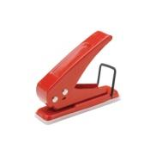
* Highlighters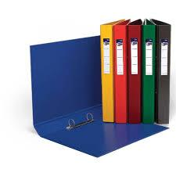
* A pencil case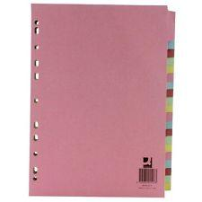
* Your own lined paper
* A single-hole punch (available from the school shop for £1)
* A pair of scissors
* Glue
* four small ring binders and file dividers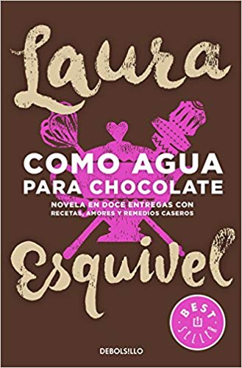

## The books you need to buy are:

* *Como Agua Para Chocolate*, Laura Esquivel. Publisher**:** Debolsillo (16 May 2016).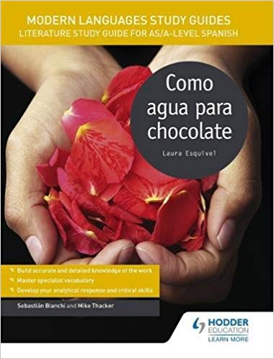

* *Modern Languages Study Guides: Como agua para chocolate: Literature Study Guide for AS/A-level Spanish (Film and literature guides)* Paperback by Sebastian Bianchi (Author), Mike Thacker (Author) Hodder Education.

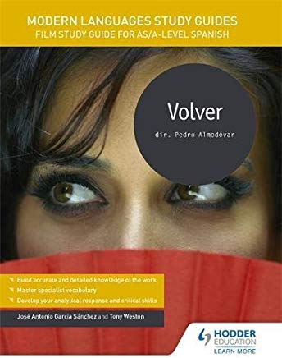

* *Modern Languages Study Guides: Volver: Film Study Guide for AS/A-level Spanish (Film and literature guides)* by José Antonio García Sánchez (Author), Tony Weston (Author) Hodder Education.

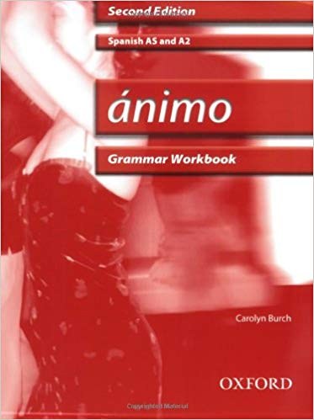

* *Ánimo: Grammar Workbook* & CD-ROM Paperback – 21 Feb 2008

# Your Summer Bridging Work Project:

We expect you to do a lot of **independent work** and self study. You all have different strengths & development points, and it is up to you to address these. Let me know if you are struggling & need extra input. My email is [rbo@cheney.oxon.sch.uk](mailto:rbo@cheney.oxon.sch.uk).

As part of a more independent approach to learning you should expect to make your own **notes** in class without being asked. Make sure as much new vocabulary as possible is recorded and then learnt. Also be sure to make notes on facts about each topic area.

Lessons will be **conducted in Spanish** for the majority of the time – please make the effort to talk to us and each other in Spanish! Now, let’s get started so you are confident when you come back...

**Core grammar task**

* Write a Spanish grammar Bible which should include notes on:

i) present regular – ar / er / ir verbs

ii) stem-changing verbs (present)

iii) irregular present tense verbs (hacer, ir, ser, tener, estar, poder)

iv) the present continuous

v) reflexive verbs

vi) the preterite

vii) the imperfect

viii) the perfect

ix) the future tense (e.g. seré) and the near future tense (e.g. voy a ser)

x) the past perfect

xi) the conditional

xii) the present subjunctive

Each tense should be clearly explained on an A4 page.

**You should explain a) how these are formed**

**b) when they are used**

**c) patterns and exceptions**

**d) tips on how to remember them.**

**Revise all this over the summer in preparation for a test first lesson in September!**

**Core Reading and Listening Tasks**

* Go to [www.euronews.com](http://www.euronews.com) at least once a week and watch videos to keep up to date with Spanish current affairs. Read the transcript if you find listening too difficult. Choose at least one event over the summer that you will be presenting to the class.
* Read a photocopy of *Rita y los ladrones de tumbas* - handed out in June. Look up words you don’t know and write them on the page. I should see on average at least 10 words per page.

**Extension tasks**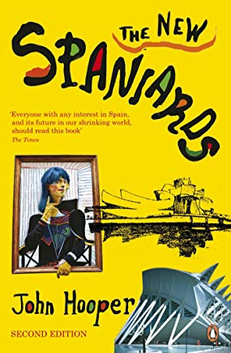

* Read John Hooper's *The New Spaniards* which is a history of Spain and focuses on the period from the end of the civil war (1939) to the recent past. Knowing about this will be a great help to you next year.
* Read three or more articles online from the *El País* website. Prepare a 1 minute presentation on one of them.
* For further challenge, you could try reading any of the following books. They are all on the A level reading list.

● *Bodas de sangre*,Federico García Lorca, 1932 (play)

● *El coronel notiene quien le escriba, Gabriel García Márquez*, 1961 (novella)

● *La casa de Bernarda Alba, Federico García Lorca*, 1936 (play)

● *Nada, Carmen Laforet*, 1943(novel)

● *Primera memoria*,Ana María Matute 1959(novel)

● *Réquiem Por Un Campesino Español*, Ramón J. Sender,1953(novella)

You could also try to watch these films:

● *Diarios De Motocicleta*,dir. Walter Salles(2004)

● *El Laberinto Del Fauno*,dir. Guillermo del Toro(2006)

● *La Lengua Las Mariposas*,dir. José Luis Cuerda(1999)

● *La Misma Luna*,dir.Patricia Riggen(2007)

● *Mar adentro*,dir. Alejandro Amenábar(2004)

● *También La Lluvia*,dir. Icíar Bollaín(2010)

**Staff contact: Dr. Bown rbo@cheney.oxon.sch.uk**

**Exam board:** EDEXCEL

**Specification:** A level Spanish